Communication Management Plan
WAH For Hospitals (WAH4H)

Asia Pacific College (Pseudoers BSCS-SS231 Group)
3 Humabon Place, Magallanes
Makati City, Metro Manila 1232

April 15, 2026

Table of Contents
Introduction 3
Communications Management Approach 3
Communications Management Constraints 4
Stakeholder Communication Requirements 5
Roles 6
Project Team Directory 7
Communication Methods and Technologies 8
Communications Matrix 10
Communication Flowchart 11
Guidelines for Meetings 11
Communication Standards 13
Communication Escalation Process 14
Glossary of Communication Terminology 15

Introduction
The purpose of the Communications Management Plan is to define the communication requirements for the project and how information will be distributed. This plan sets the communications framework for the WAH4H deployment project and will serve as a guide for communications throughout the 8-week MVP deployment life cycle.

The Communications Management Plan defines the following:
- What information will be communicated—to include the level of detail and format.
- How the information will be communicated—in meetings, email, telephone, web portal, etc.
- When information will be distributed—the frequency of project communications both formal and informal.
- Who is responsible for communicating project information.
- Communication requirements for all project stakeholders.
- An escalation process for resolving any communication-based conflicts or issues.

Communications Management Approach
The Project Manager (Elijah Josh Quibin) will take a proactive role in ensuring effective communications on this project. The communications requirements are documented in the Communications Matrix presented in this document, which will be used as the guide for what information to communicate, who is to do communication, when to communicate it and to whom to communicate. As the project matures and additional requirements are needed, the project manager is responsible for managing all proposed and approved changes to the communications management plan.

Communications Management Constraints
Schedule: Communication activities will occur in accordance with the frequencies detailed in the Communication Matrix to ensure the project adheres to the strict 8-week MVP schedule constraints. Any deviation of these timelines may result in schedule delays and must be approved by the project sponsor.

Confidentiality: WAH organizational policy states that sensitive health data or infrastructure credentials must be protected. Only authorized WAH IT personnel or executives may authorize the distribution of confidential information.

Budget: All project communication activities will occur within the project’s approved budget (zero-cost academic tools) and resource allocations.

Stakeholder Communication Requirements
As part of identifying all project stakeholders, the project manager will communicate with each stakeholder to determine their preferred frequency and method of communication. This feedback will be maintained by the project manager in the project’s Stakeholder Register. Standard project communications will occur in accordance with the Communication Matrix; however, depending on the identified stakeholder communication requirements, individual communication is acceptable.
Roles
- Project Sponsor (Pey Canlas): The project sponsor is the champion of the project. Since the Project Sponsor is at the executive level, communications should be presented in summary format unless more detailed communications are requested.
- Program Manager / Academic Liaison (Jose Eugenio Quesada): Oversees the project at the portfolio/academic level. Requires more detailed communications regarding academic milestones and progress.
- Key Stakeholders (WAH Executives): Executive management with an interest in the project and key users identified for participation.
- Change Control Board (WAH IT / Myk Martinez): A designated group which reviews technical specifications and authorizes changes within the organization's infrastructure (e.g., Linode servers).
- Customer (WAH Subscribers / Hospitals): As the customer who will be accepting the final deliverable of this project, they will be informed of the project status including potential impacts to the product itself.
- Project Manager (Elijah Josh Quibin): Has overall responsibility for the execution of the project and is the primary communicator distributing information according to this plan.
- Project Team (Nicolas, Jajurie, Chavez): Comprised of all persons who have a role performing work on the project. Requires a detailed level of communications achieved through day-to-day interactions and weekly Agile ceremonies.
- Technical Lead: Designated to be responsible for ensuring that all technical aspects of the project are addressed and implemented in a technically sound manner.

Project Team Directory
The following table presents contact information for all people identified in this communications management plan. The email addresses and phone numbers in this table will be used to communicate with these people.

Role | Name | Title | Organization/ Department | Email | Phone
Project Sponsor | - Pey Canlas | Executive Director | WAH | [Email] | [Phone]
Academic Liaison | - Jose Eugenio Quesada | Faculty / Liaison | APC | jlquesada@apc.edu.ph | [Phone]
Project Manager | - Elijah Josh Quibin | Project Manager | Pseudoers / APC | epquibin@student.apc.edu.ph | [Phone]
Project Stakeholders | See Stakeholder Register | See Stakeholder Register | See Stakeholder Register | See Stakeholder Register | See Stakeholder Register
Customer | WAH Subscribers | End Users | Various Hospitals | N/A | N/A
Project Team | Nicolas, Jajurie, Chavez | Developers | Pseudoers / APC | jrnicolas@student.apc.edu.ph | [Phone]
Technical Lead | Myk Martinez | IT Head | WAH IT

Communication Methods and Technologies
The project team will determine the communication methods and technologies based on several factors, including stakeholder requirements and available internal/external technologies
- Task Management & Collaboration: The project uses OpenProject and GitHub to collaborate on project work and communication.
- File Storage: All project communication and documentation will be archived on a shared Google Drive/OneDrive repository.
- Instant Messaging: Discord/MS Teams will be utilized for daily, informal communication among the Project Team.

Communications Matrix
The following table identifies the communications requirements for this project.

Communication Type | Objective of Communication | Medium | Frequency | Audience | Owner | Deliverable | Format
Sprint Planning / Kickoff | Introduce goals for the iteration and review objectives. | - Video Call | Bi-Weekly | - Project Team | Project Manager | - Agenda  - Sprint Backlog | - Sprint Planning / Kickoff
Daily Standup | Review status of the project with the team. | - Chat / Call | Daily | - Project Team | Project Manager | - Status Update | - Text / Chat Log
Technical Design Syncs | Discuss and develop technical design solutions (e.g., Server configs). | - · Video Call | As Needed | - Tech Lead  - PM  - Dev Team | Technical Lead | - Technical Lead | - Technical Lead
Milestone / Status Review | Report on the status of the project to management. | - · Video Call | Monthly / End of Sprint | - Project Sponsor  - Academic Liaison | Project Manager | - Re· Slide updates  - Status Report | - Standard presentation format

Communication Flowchart

The communication flowchart below was created to aid in project communication. This flowchart provides a framework for the project team to follow for this project. However, there may be occasions or situations which fall outside of the communication flowchart where additional clarification is necessary. In these situations the Project Manager is responsible for discussing the communication with the Project Sponsor and making a determination on how to proceed.

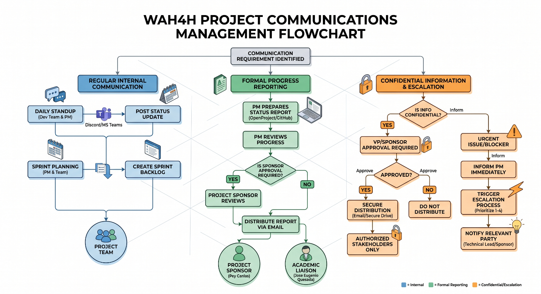

Guidelines for Meetings

Guidelines for Meetings
- Meeting Agenda: Will be distributed in advance. The first item should be a review of action items from the previous meeting.
- Meeting Minutes: Will be distributed following the meeting, including the status of all agenda items, new action items, and the Parking Lot list.
- Action Items: Include the action item along with the owner. Meetings end with a review of all new action items.
- Chair Person: The PM is responsible for distributing the agenda, facilitating the meeting, and ensuring it starts and ends on time.
- Note Taker: Responsible for documenting status, maintaining a Parking Lot, and giving notes to the Chair Person.
- Time Keeper: Helps the facilitator adhere to time limits.
- Parking Lot: A tool to record and defer items not on the agenda that merit further discussion later.

Communication Standards
For this project, the team will utilize standard organizational formats and templates for all formal project communications.

Communication Escalation Process
While escalations are a normal part of project management, there must be a documented process that defines how those escalations will take place. The table below defines the priority levels, decision authorities, and timeframes for resolution.

Priority | Definition | Decision Authority | Timeframe for Resolution
Priority 1 | Major impact to project. If not resolved quickly there will be a significant adverse impact to schedule. | Project Sponsor / Academic Liaison | Within 4 hours
Priority 2 | Medium impact to project which may result in some adverse impact to schedule. | Technical Lead / WAH IT | Within one business day
Priority 3 | Slight impact which may cause some minor scheduling difficulties. | Project Manager | Within two business days
Priority 4 | Insignificant impact to project but there may be a better solution. | Project Manager | Work continues and any recommendations are submitted via the project change control process
** NOTE: Any communication including sensitive and/or confidential information will require escalation to VP level or higher for approval prior to external distribution.

Glossary of Communication Terminology
Term | Definition
Communication | The effective sending and receiving of information. Ideally, the information received should match the information sent. It is the responsibility of the sender to ensure this takes place.
Stakeholder | Individuals or groups involved in the project or whose interests may be affected by the project’s execution or outcome.
Communications Management Plan | Portion of the overall Project Management Plan which details how project communications will be conducted, who will participate in communications, frequency of communications, and methods of communications.
Escalation | The process which details how conflicts and issues will be passed up the management chain for resolution as well as the timeframe to achieve resolution.
Sponsor Acceptance

Approved by the Project Sponsor:

Date:
<Project Sponsor>
<Project Sponsor Title>

This free Project Communications Management Plan Template is brought to you by

